EC2 classification by payment models:

1. On demand or capacity reservation:
- These instances work as pay as you go model.
- long time commitment is not required for this instance.
- These are bit costlier
2. Spot instances:
- These are called as bidding instances.
- We can bid these instances as per the requirement.
3. Dedicated hosts:
- Basically, dedicated instances are provided with the hardware configurations.
4. Reserved instances:
- These are utilized for the longer time frame.
- These would be having discounts in terms of pricing because of longer utilization time frame.
- Will get to know platform, tenancy, instance type and payment options for reserved instances.

Classification of EC2 by configuration:
GENERAL PURPOSE:
These instances are ideal for applications that use these resources in equal proportions such as web servers and code repositories.
Series: t2, T3, M4 A1.
Compute Optimized:
well suited for High performance computing (HPC), batch processing, ad serving, video encoding, gaming, scientific modelling, distributed analytics, and CPU-based machine learning inference.
Series: c7g , c6g , c6i , c6a
Memory Optimized:
Memory optimized instances are designed to deliver fast performance for workloads that process large data sets in memory.
Series: R6g, R6i, R5
Accelerated Computing:
Machine learning, high performance computing, computational fluid dynamics, computational finance, seismic analysis, speech recognition, autonomous vehicles, and drug discovery.
Series: p4, p3, p2, Dl1.
Storage Optimized:
These instances maximize the number of transactions processed per second (TPS) for I/O intensive and business-critical workloads which have medium size data sets and can benefit from high compute performance and high network throughput such as relational databases (MySQL, MariaDB, and PostgreSQL), and NoSQL databases (KeyDB, Scylla DB, and Cassandra).
Series : l4i , l3 , I3N , D2 , D3.

AMI:
Amazon Machine Image (or AMI) offers an easy and visual mode of launching instances of your virtual machine on the cloud platform.
Additionally, you can use AMI to create multiple instances of different virtual machines when you require instances of different configurations, we can also create our own custom AMI
Can you illustrate the relationship between an instance and AMI?
With the help of just a single AMI, you can launch multiple instances and that to even different types. At the same time, an instance type is characterized by the host.
Can you define EIP?
EIP stands for Elastic IP address.
It is a static Ipv4 address that is provided by AWS to administer dynamic cloud computing services.
Can you name some AWS services that are not region-specific?
- IAM
- Route 53
- Web application firewall
- CloudFront
- S3 bucket

AWS STORAGE:
1. EBS (Elastic Block Storage): EBS provides simple, scalable, high available block storage. EBS can only attach to one EC2 system. It is a block storage.
Storage space sharing is not possible in EBS.
An EBS Snapshot refers to a point-in-time copy of an Amazon Elastic Block Store (EBS) volume. Amazon EBS provides block-level storage volumes for use with EC2 instances. EBS Snapshots are a key feature of Amazon EBS, offering data backup, disaster recovery, and data migration capabilities.
Important 3 models of EBS:
- Provision IOPS (64000)
- General purpose (16000)
- Magnetic (5000)
Note: EBS can be attached to only one instance, EBS and Volume should be there in same region to avail the EBS
Benefits of EBS:
- SSD storage technology (solid-state drive)
- Highly available, fast and scalable
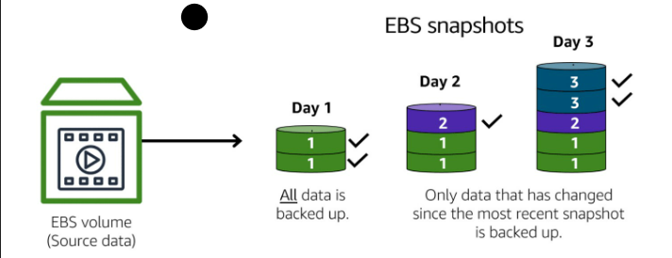

EBS Type | Category | Performance | Best Use Case
gp3 | General Purpose SSD | Up to 16,000 IOPS, 1,000 MB/s | Default choice, apps, DBs
gp2 | General Purpose SSD | IOPS tied to size | Legacy general workloads
io2 | Provisioned IOPS SSD | Up to 256,000 IOPS | Mission-critical DBs
io1 | Provisioned IOPS SSD | High IOPS (older gen) | Legacy high-IOPS apps
st1 | Throughput Optimized HDD | High throughput | Big data, log processing
sc1 | Cold HDD | Lowest cost | Infrequent access data
magnetic (standard) | HDD (deprecated) | Lowest performance | Not recommended

2. EFS (Elastic File System): It is similar to shared disk, EFS is more used in case of sharing the disk space. EFS storage is used in cluster management in order to have availability. Storage space sharing is possible in EFS and not possible in EBS Eg – Cassandra cluster, Kubernetes, Machine learning and AWS lambda. Advantages of EFS: cost effective, Speed, Disk share.

AWS-S3-Bucket:
It is basically an object storage. S3 cannot hold data, but it can store & hold data which are in form of objects. S3 is not region specific. We can host static website on S3.

Types of S3 buckets:

- S3 Standard
- S3 Standard-IA (infrequent Access)
- S3 Intelligent-Tiering
- S3 One Zone-IA
- S3 Glacier
- S3 Glacier Deep Archive
- S3 Outposts

S3 Versioning:
Versioning – AWS S3 is a means of keeping multiple variants of an object in same bucket, you can use the S3 versioning feature to preserve, retrieve and restore every version of every object stored in your bucket. Versioning enabled buckets can help you recover objects from accidental deletion or overwrite.

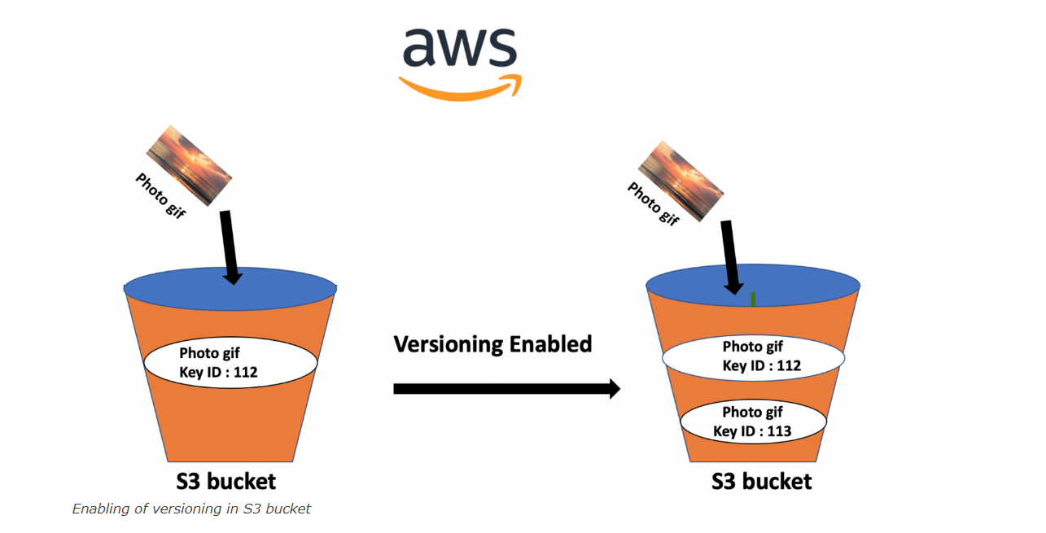

S3 LIFE_CYCLE_MANAGEMENT:

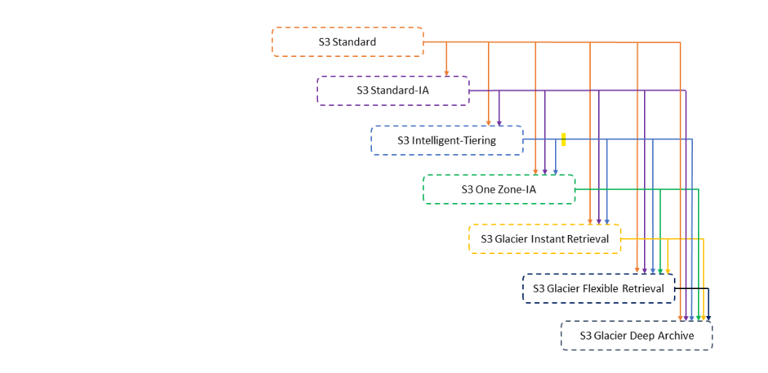

Lifecycle management provides two features – Transition Actions and Expiration Actions.

- Transition actions moves data from one storage class to another storage class of s3 buckets
- On the other hand, Expiration Actions configure to move data from one storage class to another at a defined time interval or at a defined schedule.
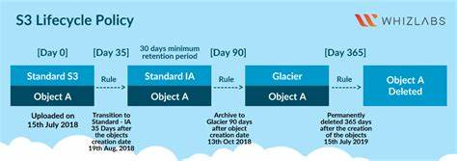

Common Use Cases:
1️⃣ Application file storage
- EC2 runs the application
- S3 stores images, videos, documents, uploads
2️⃣ Backup and recovery
- EC2 takes backups (database, files)
- Backups are stored safely in S3
3️⃣ Log storage
- EC2 generates logs
- Logs are pushed to S3 for long-term storage
4️⃣ Data processing
- S3 stores input data
- EC2 processes the data
- Output is saved back to S3
5️⃣ Software and script storage
- Application packages stored in S3
- EC2 downloads them during startup or deployment
6️⃣ File sharing between EC2 instances
- One EC2 uploads files to S3
- Other EC2 instances download from S3

IAM (Identity Access management)

IAM allows you to manage users and their level of access to AWS console.
Key components of IAM

- Users – Users are end users within an organization.
example – developers, tester and infrastructure ppl.
- User group – User group are collection of users, each user in the group will inherit the permission of the group.
- Policies – Policies are made up of documents called policy document, these documents are in the format of json and they give permission as to what a user group or a role is able to do.
- IAM role – It is an IAM entity that defines a set of permission making AWS service request. It is not
associated with specific user or groups.

Advantages of IAM
- It provides centralized control of your AWS account.
- Shared access to your AWS account.
- Multi factor authentication.
- Identity federation

What is Transit Gateway?
AWS Transit Gateway is a central networking hub that connects multiple VPCs, VPNs, and
on-prem networks and enables transitive routing.
Why Transit Gateway is required when VPC Peering exists?
• VPC Peering is point-to-point (one-to-one)
• No transitive routing support
• Becomes complex as VPC count increases (mesh problem)
• No centralized routing or security control

How Transit Gateway solves this
• Uses hub-and-spoke architecture
• All VPCs connect to one gateway
• Supports transitive routing
• Centralized route tables and traffic control
• Easy on-prem integration via VPN / Direct Connect

Advantages of Transit Gateway
• Highly scalable (hundreds of VPCs)
• Simplified network architecture
• Centralized routing and security
• Enterprise and hybrid-cloud ready
• Reduced operational overhead

Transit Gateway vs VPC Peering
VPC Peering: Mesh, no transitive routing, low scalability
Transit Gateway: Hub-and-spoke, transitive routing, high scalability

